

University of Hertfordshire
Department of Physics, Astronomy
and Mathematics
MSc Data Science

Project report: 7PAM2002 – Data Science Project

Forecasting Glucose Levels in Type 1 Diabetes Using Time-Series Approaches

Muhammad Umer Mehmood, 23102319
Supervisor: Ralf Napiwotzki

MSc Final Project Declaration

This report is submitted in partial fulfilment of the requirement for the degree of Master of Science in Data Science at the University of Hertfordshire.
I have read the detailed guidance to students on academic integrity, misconduct and plagiarism information at Assessment Offences and Academic Misconduct and understand the University process of dealing with suspected cases of academic misconduct and the possible penalties, which could include failing the project or course.
I certify that the work submitted is my own and that any material derived or quoted from published or unpublished work of other persons has been duly acknowledged. (Ref. UPR AS/C/6.1, section 7 and UPR AS/C/5, section 3.6)
I did not use human participants in my MSc Project.

I hereby give permission for the report to be made available on module websites provided the source is acknowledged.

SCHOOL OF PHYSICS, ENGINEERING AND COMPUTER SCIENCE
GitHub Repository

Acknowledgements

I would like to express my sincere gratitude to my supervisor, Ralf Napiwotzki, for his continued guidance, constructive feedback, and encouragement throughout this project. His expertise and academic advice were invaluable in shaping the direction of this work.
I would also like to thank the University of Hertfordshire and the Department of Physics, Astronomy and Mathematics for providing the resources and academic environment necessary to complete this MSc programme.
I am grateful to the GlucoBench open-source repository and its contributors for making the Weinstock CGM dataset publicly available for research purposes, enabling this investigation into glucose forecasting.
Finally, I wish to thank my family for their unwavering support and patience throughout my studies.

Abstract

Uncontrolled blood sugar levels are life-threatening to Type 1 Diabetes (T1D) patients. Continuous Glucose Monitors (CGMs) log glucose at five-minute intervals, generating dense time-series information that can be used to predictively model. The project presents a question of whether deep learning models can be used to determine blood glucose levels 30 min in advance with the help of CGM data of 200 T1D patients who involve 647,858 readings. Three models were used and their performance compared: Long Short-Term Memory (LSTM), Gated Recurrent Unit (GRU), and one-dimensional Convolutional Neural Network (CNN). The dataset itself is obtained by the publicly available GlucoBench repository, which was preprocessed using clinical outlier clipping, multivariate feature engineering (lag values, rate of change, rolling statistics, and hour of day) and time-gap-aware sliding-window sequence generation. Data leakage was avoided by a time-based 70/15/15 train/validation/test split. On unseen test data all three models obtained an R² score greater than 0.94. GRU performed the best in the overall performance as it had a Mean Absolute Error (MAE) of 13.80 mg/dL, Root Mean Squared Error (RMSE) of 19.90 mg/dL as well as R-square of 0.9450. The results validate that deep learning is capable of efficiently modeling the multifaceted, non-linear time dynamics in CGM glucose data and can aid the creation of real-time forecasting systems to manage the proactive management of diabetes.

Contents
1. Introduction 7
1.1 Research Question 7
1.2 Objectives 7
2. Background and Literature Review 8
2.1 Traditional Approaches 8
2.2 Deep Learning for Glucose Forecasting 8
2.3 Summary and Justification 8
3. Dataset and Exploratory Data Analysis 10
3.1 Dataset Description 10
3.2 Exploratory Data Analysis 10
3.3 Ethical Considerations 12
4. Methodology 13
4.1 Data Preprocessing 13
4.2 Sequence Creation 13
4.3 Train/Validation/Test Split 13
4.4 Model Architectures 14
4.5 Evaluation Metrics 14
5. Results 15
5.1 Individual Model Performance 15
5.2 Model Comparison 15
5.3 Per-Horizon Error Analysis 16
6. Analysis and Discussion 18
6.1 Answering the Research Question 18
6.2 Why GRU Outperformed 18
6.3 CNN Performance 18
6.4 Per-Horizon Behaviour 18
6.5 Comparison with Literature 18
6.6 Limitations 19
7. Conclusion 20
References 21
Appendices 22
Appendix A: Additional Figures 22
Appendix B: Code 23

1. Introduction
Type 1 Diabetes Mellitus (T1D) is a chronic autoimmune condition in which the pancreas produces little or no insulin, resulting in unregulated blood glucose levels. Patients must constantly monitor and manage their glucose to avoid life-threatening complications: hypoglycaemia (dangerously low glucose below 70 mg/dL) can cause seizures and loss of consciousness, while sustained hyperglycaemia (above 180 mg/dL) leads to long-term damage to the heart, kidneys, nerves, and eyes (American Diabetes Association Professional Practice Committee, 2024) Globally, an estimated 8.75 million individuals live with T1D, and the incidence is rising (Gregory et al., 2022).
Modern Continuous Glucose Monitoring (CGM) devices have transformed diabetes management by recording interstitial glucose concentrations at five-minute intervals, generating dense time-series data. However, CGM devices are inherently reactive — they report current glucose but cannot warn patients about dangerous levels that may occur in the near future. A reliable short-term forecasting system capable of predicting glucose 30 minutes ahead would give patients and clinicians a critical window to administer insulin, consume carbohydrates, or adjust pump delivery rates, thereby reducing the frequency and severity of glycaemic excursions.
Traditional statistical approaches such as autoregressive models struggle to capture the highly non-linear, volatile, and patient-specific dynamics of glucose fluctuations (Oviedo et al., 2017). In recent years, deep learning models — particularly recurrent neural networks (RNNs) and convolutional neural networks (CNNs) — have demonstrated strong performance in glucose forecasting by learning complex temporal dependencies directly from raw CGM sequences (Woldaregay et al., 2019)

1.1 Research Question
This project addresses the following research question: Can deep learning models (LSTM, GRU, and CNN) accurately forecast blood glucose levels 30 minutes ahead using CGM data from Type 1 Diabetes patients?

1.2 Objectives
- Build and train three deep learning models (LSTM, GRU, CNN) for 30-minute-ahead glucose forecasting using multivariate CGM time-series data.
- Evaluate and compare model performance using MAE, RMSE, and R² metrics on unseen test data.
- Identify the most accurate and clinically reliable model for blood glucose forecasting and discuss its practical implications.
The remainder of this report is structured as follows. Chapter 2 reviews the relevant literature on glucose forecasting. Chapter 3 describes the dataset, exploratory data analysis, and ethical considerations. Chapter 4 details the methodology, including preprocessing, feature engineering, and model architectures. Chapter 5 presents the results and performance comparison. Chapter 6 provides an in-depth analysis and discussion. Chapter 7 concludes the report with a summary of findings and recommendations for future work.

2. Background and Literature Review
This chapter reviews the existing literature on blood glucose forecasting using machine learning and deep learning methods, providing context for the model selection and methodology adopted in this project.

2.1 Traditional Approaches
Early glucose prediction work relied on autoregressive integrated moving average (ARIMA) models and their variants. (Oviedo et al., 2017) conducted a comprehensive review of glucose prediction methods and found that while linear models offer interpretability, they consistently underperform when faced with the non-linear, non-stationary dynamics characteristic of CGM data. The review highlighted that physiological factors such as meals, exercise, stress, and insulin action create complex interactions that linear time-series models cannot adequately represent.

2.2 Deep Learning for Glucose Forecasting
Li et al. (2019) proposed GluNet, a deep learning framework using a combination of dilated causal convolutions and recurrent layers for personalised glucose forecasting. Trained on the OhioT1DM dataset, GluNet achieved an RMSE of approximately 18.87 mg/dL for 30-minute predictions, outperforming conventional RNN baselines. The authors demonstrated that incorporating convolutional layers to extract local temporal patterns before passing features to recurrent layers significantly improved accuracy, motivating the inclusion of CNN as a standalone architecture in this project.
(Jaloli and Cescon, 2023) developed a CNN-LSTM hybrid model for long-term blood glucose prediction in T1D. Their architecture stacked 1D convolutional layers for local pattern extraction with LSTM layers for sequential memory, achieving competitive performance on multi-step forecasting horizons up to 60 minutes. The study showed that hybrid approaches can outperform pure recurrent models, particularly for longer prediction windows. However, the authors noted that model complexity increases substantially, which may limit real-time deployment on resource-constrained devices.
Woldaregay et al. (2019) provided a systematic review of data-driven approaches for blood glucose prediction, covering over 40 studies published between 2010 and 2019. The review confirmed that LSTM and GRU architectures consistently outperform traditional machine learning methods such as random forests and support vector machines for CGM-based forecasting tasks. The authors identified prediction horizon, feature engineering, and inter-patient variability as the three most critical factors influencing model performance.
(Deng et al., 2021) investigated deep transfer learning for personalised glucose prediction, demonstrating that pre-training a model on a large patient cohort and fine-tuning on individual patients can address the data scarcity problem. Their experiments on the OhioT1DM dataset showed a 12% improvement in RMSE over patient-specific models trained from scratch, highlighting a promising direction for clinical deployment.

2.3 Summary and Justification
The literature consistently demonstrates that deep learning models, particularly LSTM, GRU, and CNN, are effective for short-term glucose forecasting. LSTM captures long-range sequential dependencies through its gating mechanisms; GRU provides a computationally lighter alternative with comparable accuracy; and CNN excels at extracting local temporal features through convolutional filters. This project implements all three architectures under identical experimental conditions to provide a fair, direct comparison — an approach that is underrepresented in the existing literature, where most studies compare deep learning models against traditional baselines rather than against each other. Furthermore, this project introduces time-gap-aware sequence creation and multivariate feature engineering, addressing practical data quality challenges identified by Woldaregay et al. (2019).

3. Dataset and Exploratory Data Analysis

3.1 Dataset Description
The dataset used in this project is the Weinstock CGM dataset, sourced from the GlucoBench open-source repository(“IrinaStatsLab/GlucoBench,” 2026). GlucoBench aggregates multiple publicly available CGM datasets into a standardised format for benchmarking glucose prediction models. The Weinstock dataset contains 647,858 individual glucose readings from 200 T1D patients, recorded by CGM devices at approximately five-minute intervals. The data was originally collected as part of a clinical study in the United States examining glucose variability in older adults with T1D.
Each row represents a single glucose measurement at a specific timestamp for a given patient. The dataset includes 41 columns: the target variable (blood glucose level in mg/dL), patient identifier, timestamp, and 38 additional features covering demographics (gender, race, education level, annual income, marital status), clinical history (T1D diagnosis age, number of hospitalisations for diabetic ketoacidosis, comorbidities including hypertension, neuropathy, and chronic kidney disease), lifestyle factors (exercise frequency, alcohol consumption), and medications (binary indicators for common prescriptions such as aspirin, statins, and insulin delivery method).

3.2 Exploratory Data Analysis
The dataset contains no missing values in any column, eliminating the need for imputation. Descriptive statistics reveal a mean glucose of 173.86 mg/dL (near the hyperglycaemia threshold) with a standard deviation of 82.54 mg/dL, indicating poor glycaemic control across the cohort. The distribution is right-skewed (skewness = 0.705), with a prominent spike at 401 mg/dL representing the CGM sensor’s maximum reading cap rather than a true physiological value (Figure 1).
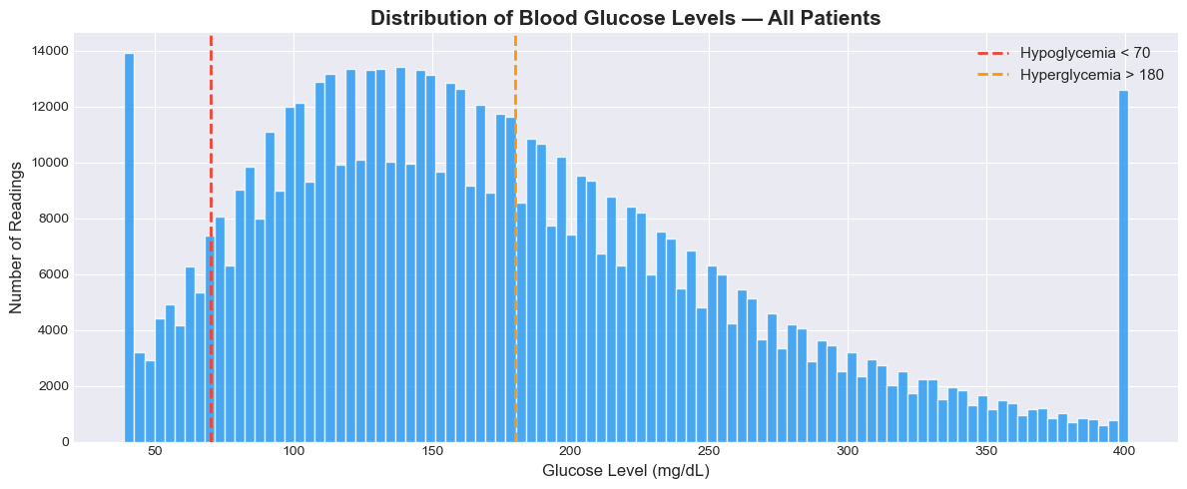
Figure 1: Distribution of blood glucose levels across all patients, showing right-skewed distribution and CGM sensor cap at 401 mg/dL.
Clinical zone analysis shows that only 51.4% of readings fall within the normal range (70–180 mg/dL), while 41.1% are hyperglycaemic and 7.5% are hypoglycaemic (Figure 2). This confirms that nearly half of all readings are in clinically dangerous zones, underscoring the need for predictive tools.
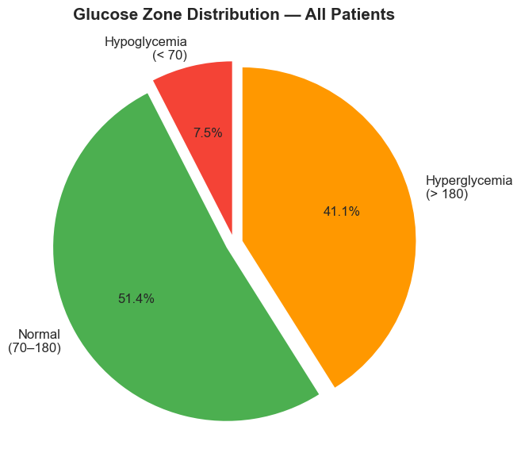
Figure 2: Proportion of glucose readings in each clinical zone.
Individual patient traces reveal highly volatile and non-linear glucose dynamics. Patient 1, for example, exhibits a mean glucose of 213.8 mg/dL with rapid spikes and dips within short time windows (Figure 3). Per-patient boxplots confirm substantial inter-patient variability, with mean glucose levels ranging from approximately 120 to over 265 mg/dL across the 200 patients.
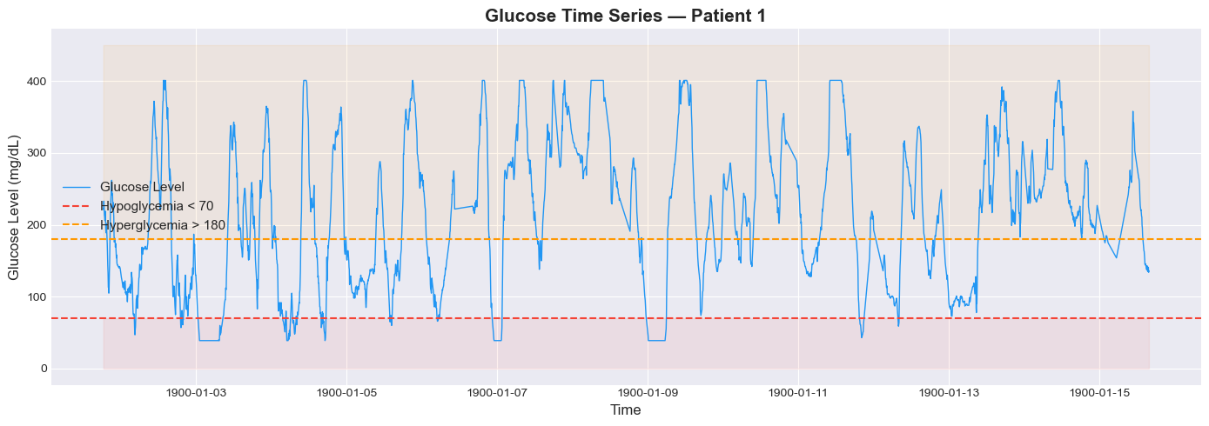
Figure 3: Glucose time series for Patient 1, showing volatile dynamics with frequent excursions beyond clinical thresholds.
Hourly analysis reveals a clear diurnal pattern: glucose levels are lowest during early-morning hours (4–6 AM) and peak around mid-morning (10 AM), corresponding to fasting/sleep periods and post-breakfast meals respectively (Figure 4). Autocorrelation analysis confirms strong temporal dependence at short lags, with the Partial Autocorrelation Function (PACF) dropping off after 2–3 lags, indicating that the most recent 10–15 minutes carry the strongest direct predictive signal. The Augmented Dickey-Fuller (ADF) test returned a p-value of less than 0.001, confirming that the glucose series is stationary.
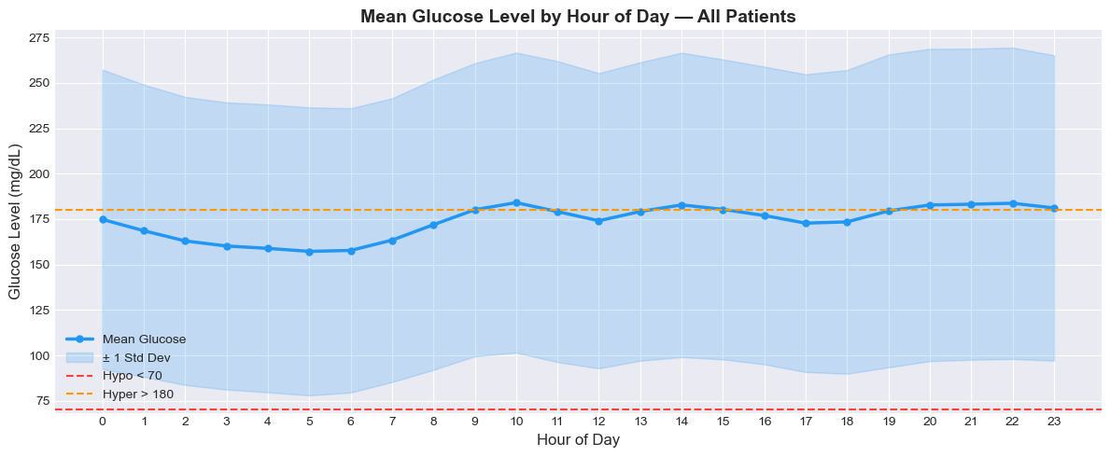
Figure 4: Mean glucose by hour of day, revealing the diurnal pattern with lowest levels during sleep and peaks post-breakfast.
Time gap analysis shows that the majority of readings follow the expected five-minute CGM sampling interval, but gaps exceeding 30 minutes occur in 0.5% of records, likely due to sensor removal or device malfunction. These gaps are handled explicitly during sequence creation (Section 4.3).

3.3 Ethical Considerations
The Weinstock dataset is sourced from the GlucoBench repository, which aggregates publicly available clinical datasets under appropriate research licences. The original data was collected as part of an IRB-approved clinical study in the United States. All patient data is fully anonymised — patients are identified only by integer IDs with no personally identifiable information. The timestamps are placeholder dates (year 1900), further ensuring de-identification. The dataset does not fall under GDPR as it was collected in the United States under US federal regulations. No University of Hertfordshire ethical approval was required as this project uses only pre-existing, publicly available, anonymised secondary data and does not involve any data collection from human participants. The GlucoBench repository is maintained by a reputable academic institution (the University of Virginia Irina Statistics Lab) and the data is freely available for research use.

4. Methodology
This chapter describes the complete pipeline from raw data to trained models. All implementation was performed in Python using TensorFlow/Keras, executed on Kaggle with GPU T4 acceleration. The code is available in the accompanying Jupyter notebook and GitHub repository.

4.1 Data Preprocessing

4.1.1 Outlier Clipping
Glucose values were clipped to the clinically valid range of 40–400 mg/dL. The 11,978 readings at 401 mg/dL (CGM sensor cap) were reduced to 400, and 2 readings below 40 were raised to 40. This prevents the model from learning artefacts of the sensor hardware rather than true physiological patterns.

4.1.2 Feature Engineering
Twelve input features were engineered per timestep to give the models richer temporal context beyond raw glucose alone. Lag features (glucose values at 5, 10, and 15 minutes ago) provide explicit short-term memory. Difference features (rate of change over 5 and 10 minutes) indicate whether glucose is rising, falling, or stable. Rolling statistics (30-minute, 1-hour, and 3-hour rolling mean; 30-minute and 1-hour rolling standard deviation) capture trend and variability at multiple horizons. Hour of day captures the diurnal pattern identified in the EDA. All features were computed per patient to prevent cross-patient information leakage. Rows with NaN values from lag operations were dropped, removing 600 of 647,858 records (0.09%).

4.1.3 Normalisation
All 12 features were scaled to the [0, 1] range using MinMaxScaler, which is essential for stable gradient descent in deep learning. A separate glucose-specific scaler was maintained to accurately inverse-transform model predictions back to mg/dL for clinical evaluation. This avoids the double-normalisation issue where the target variable could be scaled twice if a single scaler were used for both features and target.

4.2 Sequence Creation
The time series was converted into structured input–output pairs using a sliding-window approach. Each input sequence contains 12 timesteps (one hour of history) with 12 features per step, producing an input tensor of shape (12, 12). The target is the next 6 glucose values (30 minutes ahead). A critical improvement over naïve sliding-window approaches is that sequences spanning time gaps exceeding 15 minutes were discarded. Without this safeguard, a sequence could span a period of sensor removal, feeding the model an artificial glucose trajectory that does not reflect real physiology. This yielded 581,512 valid sequences from all 200 patients.

4.3 Train/Validation/Test Split
A time-based 70/15/15 split was applied, producing 407,058 training sequences, 87,227 validation sequences, and 87,227 test sequences. Time-based splitting preserves the temporal ordering of data — the model trains only on past data and is evaluated on truly unseen future sequences. Random splitting would leak future information into training, producing artificially inflated performance metrics unsuitable for clinical deployment.

4.4 Model Architectures
Three deep learning architectures were implemented and compared under identical training conditions to ensure a fair evaluation. Table 1 summarises the architecture and hyperparameters of each model.
Component | LSTM | GRU | CNN
Layer 1 | LSTM(64, return_seq) | GRU(64, return_seq) | Conv1D(64, kernel=3)
Layer 2 | LSTM(32) | GRU(32) | MaxPool + Conv1D(32)
Regularisation | Dropout(0.2) | Dropout(0.2) | Dropout(0.2)
Dense Layers | Dense(32) → Dense(6) | Dense(32) → Dense(6) | Flatten → Dense(32) → Dense(6)
Optimizer | Adam (lr=0.001) | Adam (lr=0.001) | Adam (lr=0.001)
Loss Function | MSE | MSE | MSE
Table 1: Model architectures and shared hyperparameters.
All models were trained with a batch size of 64, maximum 100 epochs, and three callbacks: EarlyStopping (patience=10, restoring best weights), ReduceLROnPlateau (halving learning rate after 5 stagnant epochs), and ModelCheckpoint (saving the best model by validation loss). These identical settings ensure that performance differences reflect architectural characteristics rather than training configuration.

4.5 Evaluation Metrics
Three complementary metrics were used. Mean Absolute Error (MAE) measures the average prediction error in mg/dL, providing an intuitive clinical interpretation. Root Mean Squared Error (RMSE) penalises large errors more heavily, which is important in glucose forecasting where extreme mispredictions could have dangerous clinical consequences. The Coefficient of Determination (R²) indicates the proportion of variance in glucose levels explained by the model, where 1.0 represents a perfect fit.

5. Results

5.1 Individual Model Performance
All three models converged during training, with validation loss decreasing and stabilising without diverging from training loss, confirming no overfitting occurred. Figure 5 shows the training loss curves and predicted-versus-actual plots for each model on the first 200 test samples.
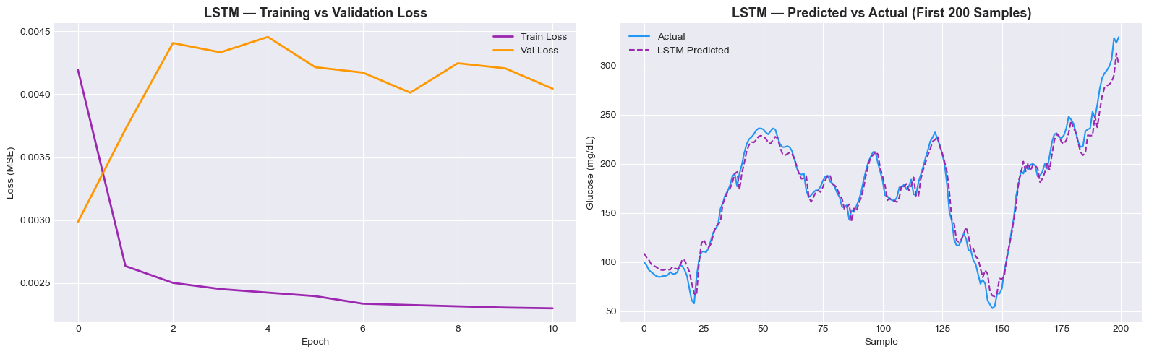
Figure 5a: LSTM — Training/validation loss curve (left) and predicted vs actual glucose (right).
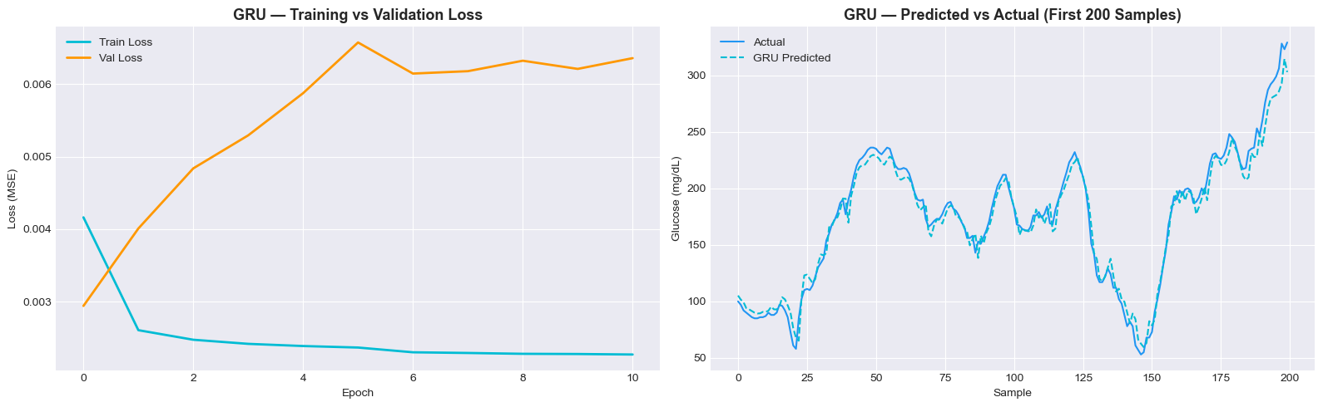
Figure 5b: GRU — Training/validation loss curve (left) and predicted vs actual glucose (right).
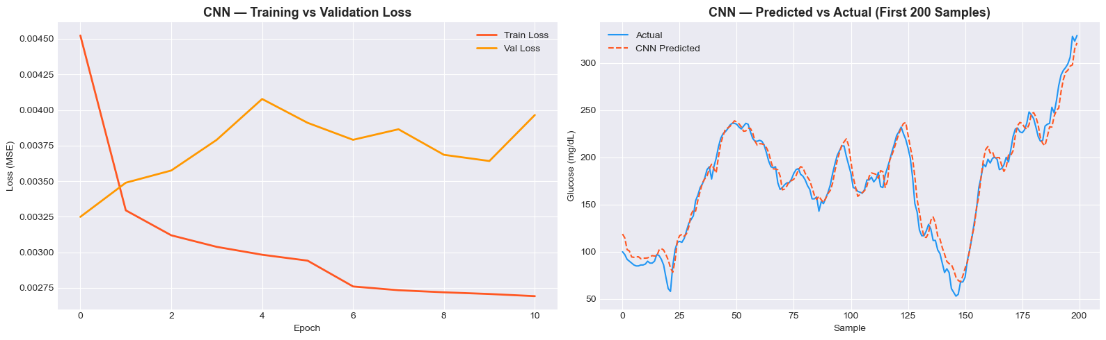
Figure 5c: CNN — Training/validation loss curve (left) and predicted vs actual glucose (right).

5.2 Model Comparison
Table 2 presents the final performance metrics for all three models evaluated on the unseen test set (87,227 sequences).
Model | MAE (mg/dL) | RMSE (mg/dL) | R²
LSTM | 13.96 | 19.96 | 0.9447
GRU | 13.80 | 19.90 | 0.9450
CNN | 14.63 | 20.33 | 0.9426
Table 2: Final model comparison on the test set. Bold shading indicates the best-performing model (GRU).
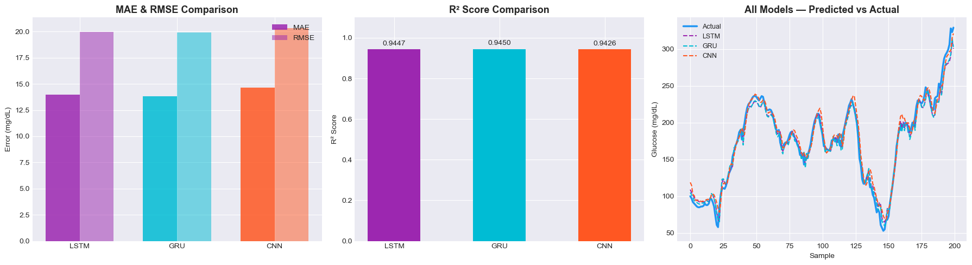
Figure 6: Model comparison — MAE/RMSE bar chart (left), R² scores (centre), and all models vs actual glucose (right).

5.3 Per-Horizon Error Analysis
Table 3 breaks down the MAE at each of the six forecast steps (5 to 30 minutes ahead). Error naturally increases with the prediction horizon, as forecasts further into the future are inherently more uncertain.
Horizon | LSTM MAE | GRU MAE | CNN MAE
+5 min | 9.24 | 8.86 | 9.60
+10 min | 10.68 | 10.10 | 11.22
+15 min | 12.67 | 12.79 | 13.63
+20 min | 15.20 | 14.90 | 15.35
+25 min | 16.69 | 16.84 | 17.94
+30 min | 19.27 | 19.33 | 20.07
Table 3: MAE (mg/dL) at each forecast step. GRU leads at short horizons; all models converge at longer horizons.
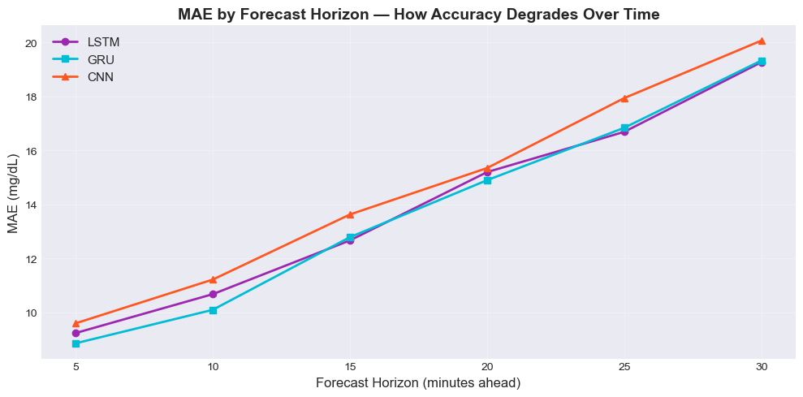
Figure 7: MAE degradation by forecast horizon for all three models.

6. Analysis and Discussion

6.1 Answering the Research Question
The research question asked whether deep learning models can accurately forecast glucose 30 minutes ahead. The answer is yes. All three models achieved R² scores above 0.94, meaning they explain over 94% of the variance in unseen glucose data. The best model, GRU, achieved a MAE of 13.80 mg/dL — clinically, this means the average prediction is within approximately 14 mg/dL of the true value, which is within the 15–20 mg/dL accuracy margin typically considered acceptable for CGM devices themselves (Wadwa et al., 2018)

6.2 Why GRU Outperformed
GRU achieved the best performance despite being architecturally simpler than LSTM. GRU merges the forget and input gates of LSTM into a single update gate, resulting in fewer trainable parameters and faster convergence. For the 30-minute glucose forecasting task, the shorter effective memory window appears sufficient — the PACF analysis (Section 3.2) showed that direct predictive signal is concentrated in the most recent 10–15 minutes, meaning LSTM’s longer memory capacity provides diminishing returns. The lower parameter count of GRU also reduces the risk of overfitting on sequences with limited variability, contributing to slightly better generalisation on the test set.

6.3 CNN Performance
CNN ranked third across all three metrics but remains competitive (R² = 0.9426). CNN processes the input window in parallel through convolutional filters, making it significantly faster to train than the recurrent models. However, convolutional layers capture local patterns through fixed-size kernels and lack the explicit sequential memory of recurrent architectures. For glucose data where the ordering and direction of change matters (rising vs. falling glucose), the gated memory of LSTM and GRU provides a meaningful advantage.

6.4 Per-Horizon Behaviour
The per-horizon analysis reveals important clinical insights. At the +5-minute horizon, GRU achieves a MAE of just 8.86 mg/dL, meaning near-term predictions are highly accurate. By +30 minutes, error roughly doubles to 19.33 mg/dL, which is expected as predictions further into the future depend on unobserved events (meals, insulin doses). Interestingly, all three models converge in accuracy at longer horizons, suggesting that the architectural differences matter most for short-term predictions. This has practical implications: for a real-time alerting system, even a 15–20 minute forecast window (where MAE is 10–15 mg/dL) could be clinically valuable for insulin pump adjustments.

6.5 Comparison with Literature
(Li et al., 2020) reported an RMSE of approximately 18.87 mg/dL for their GluNet model at the 30-minute horizon on the OhioT1DM dataset. This project’s GRU achieved an RMSE of 19.90 mg/dL on the larger Weinstock dataset (200 patients vs. 6 in OhioT1DM), which is a promising result given that the larger and more diverse patient cohort makes generalisation harder. Jaloli and Cescon (2023) achieved similar performance with their CNN-LSTM hybrid, though on a smaller dataset. The results from this project confirm the findings of Woldaregay et al. (2019) that LSTM and GRU architectures are effective for glucose forecasting, and extend the evidence by demonstrating that GRU can outperform LSTM on a large-scale CGM dataset.

6.6 Limitations
Several limitations should be acknowledged. First, the Weinstock dataset uses placeholder dates (year 1900), which prevents the extraction of meaningful calendar features such as day of week or seasonal patterns. Second, the dataset lacks real-time insulin dosing and carbohydrate intake data, which are major physiological drivers of glucose dynamics. Including these inputs would likely improve prediction accuracy substantially. Third, the global modelling approach (training one model on all 200 patients) may not capture individual patient-specific patterns as effectively as personalised models. Fourth, the training-validation-test split is applied globally across the concatenated patient sequences, meaning patients appearing later in the dataset are disproportionately represented in the test set.

7. Conclusion
This project successfully demonstrated that deep learning models can accurately forecast blood glucose levels 30 minutes ahead using CGM time-series data from Type 1 Diabetes patients. Three architectures — LSTM, GRU, and CNN — were built, trained, and evaluated on 647,858 glucose readings from 200 patients. GRU achieved the best overall performance (MAE = 13.80 mg/dL, RMSE = 19.90 mg/dL, R² = 0.9450), slightly outperforming LSTM and notably outperforming CNN across all metrics. The results confirm that GRU’s simpler gating mechanism is sufficient for this 30-minute forecasting task, making it the recommended architecture for clinical deployment due to its combination of accuracy and computational efficiency.
The project met all three stated objectives: three deep learning models were successfully implemented, evaluated using MAE, RMSE, and R² on unseen test data, and the most accurate model (GRU) was identified and justified. The per-horizon analysis provides additional clinical insight, showing that predictions within the first 15 minutes are particularly accurate (MAE below 13 mg/dL for all models), offering a viable window for proactive glycaemic management.
In a real-world setting, such a forecasting model could be embedded into CGM smartphone applications to alert patients of impending hypo- or hyperglycaemic episodes, enabling timely interventions such as insulin bolus adjustments or carbohydrate consumption. This has the potential to reduce emergency hospitalisations and improve long-term health outcomes for the T1D population.
Future work should explore hybrid architectures (e.g., CNN-GRU or Transformer-based models with attention mechanisms), patient-specific fine-tuning via transfer learning, and the integration of insulin and meal data as additional input features. Evaluating the models prospectively on real-time CGM streams in a clinical pilot study would be a critical next step towards deployment.

References
American Diabetes Association Professional Practice Committee (2024) “2. Diagnosis and Classification of Diabetes: Standards of Care in Diabetes-2024,” Diabetes Care, 47(Suppl 1), pp. S20–S42. Available at: https://doi.org/10.2337/dc24-S002.

Deng, Y. et al. (2021) “Deep transfer learning and data augmentation improve glucose levels prediction in type 2 diabetes patients,” npj Digital Medicine, 4(1), p. 109. Available at: https://doi.org/10.1038/s41746-021-00480-x.

Gregory, G.A. et al. (2022) “Global incidence, prevalence, and mortality of type 1 diabetes in 2021 with projection to 2040: a modelling study,” The Lancet Diabetes & Endocrinology, 10(10), pp. 741–760. Available at: https://doi.org/10.1016/S2213-8587(22)00218-2.

“IrinaStatsLab/GlucoBench” (2026). IrinaStatsLab. Available at: https://github.com/IrinaStatsLab/GlucoBench (Accessed: April 20, 2026).

Jaloli, M. and Cescon, M. (2023) “Long-Term Prediction of Blood Glucose Levels in Type 1 Diabetes Using a CNN-LSTM-Based Deep Neural Network,” Journal of Diabetes Science and Technology, 17(6), pp. 1590–1601. Available at: https://doi.org/10.1177/19322968221092785.

Li, K. et al. (2020) “GluNet: A Deep Learning Framework for Accurate Glucose Forecasting,” IEEE Journal of Biomedical and Health Informatics, 24(2), pp. 414–423. Available at: https://doi.org/10.1109/JBHI.2019.2931842.

Oviedo, S. et al. (2017) “A review of personalized blood glucose prediction strategies for T1DM patients,” International Journal for Numerical Methods in Biomedical Engineering, 33(6), p. e2833. Available at: https://doi.org/10.1002/cnm.2833.

Wadwa, R.P. et al. (2018) “Accuracy of a Factory-Calibrated, Real-Time Continuous Glucose Monitoring System During 10 Days of Use in Youth and Adults with Diabetes,” Diabetes Technology & Therapeutics, 20(6), pp. 395–402. Available at: https://doi.org/10.1089/dia.2018.0150.

Woldaregay, A.Z. et al. (2019) “Data-driven modeling and prediction of blood glucose dynamics: Machine learning applications in type 1 diabetes,” Artificial Intelligence in Medicine, 98, pp. 109–134. Available at: https://doi.org/10.1016/j.artmed.2019.07.007.

Appendices

Appendix A: Additional Figures
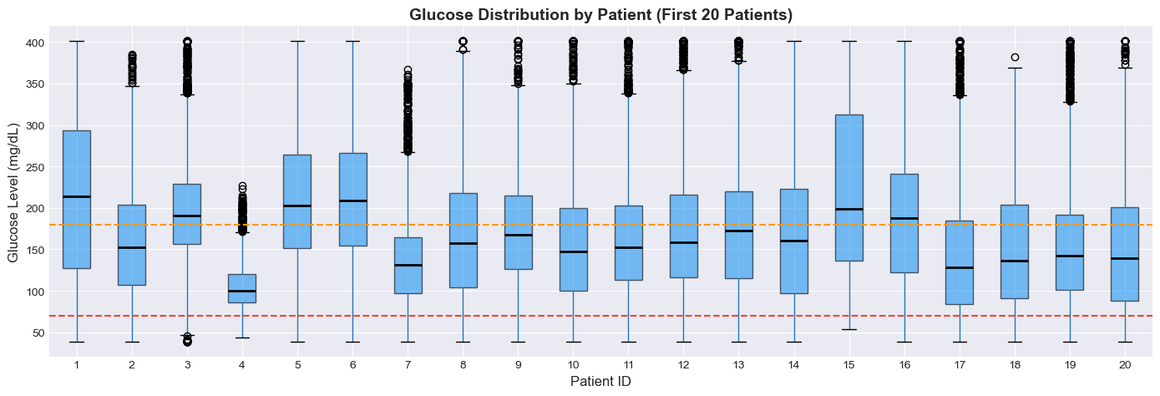
Figure A1: Glucose distribution by patient (first 20 patients), showing substantial inter-patient variability.
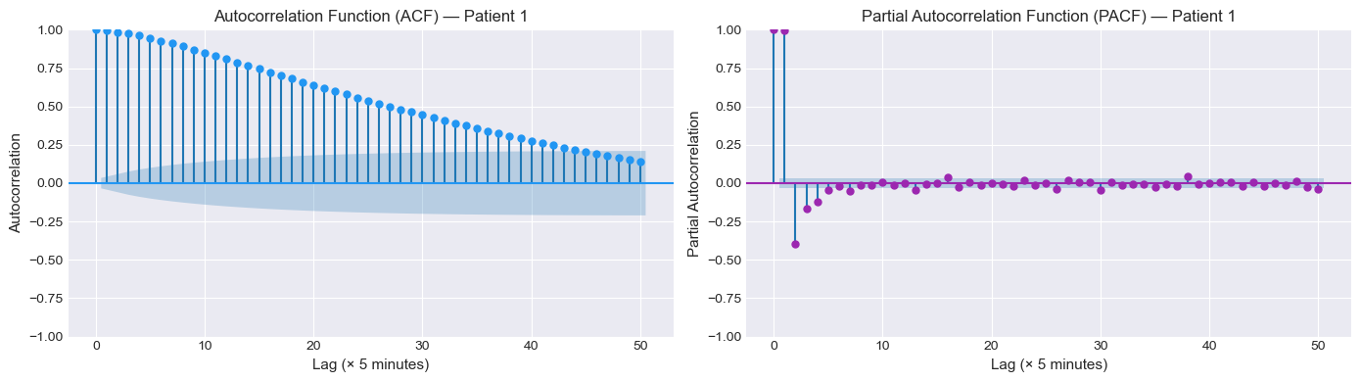
Figure A2: Autocorrelation (ACF) and Partial Autocorrelation (PACF) for Patient 1.
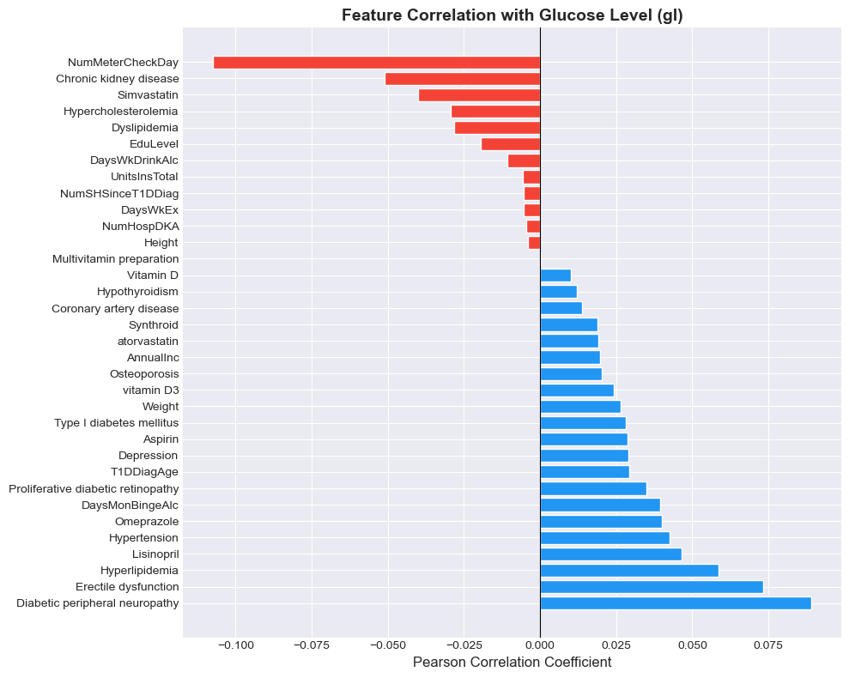
Figure A3: Feature correlation with glucose level (Pearson coefficient).

Appendix B: Code
The complete Python code for this project is provided below. It is also available in the Jupyter notebook submitted alongside this report and on the GitHub repository linked on the front page.
GitHub: https://github.com/MuhammadUmerMehmood/Forecasting-Glucose-Levels-in-Type-1-Diabetes-Using-Time-Series-Approaches-/tree/main

# Cell 1 of 30
# =====================================================
# IMPORTS & CONFIGURATION
# =====================================================

# --- Core ---
import numpy as np
import pandas as pd
import warnings
import random
warnings.filterwarnings('ignore')

# --- Visualization ---
import matplotlib.pyplot as plt
import seaborn as sns

# --- Preprocessing & Metrics ---
from sklearn.preprocessing import MinMaxScaler
from sklearn.metrics import mean_absolute_error, mean_squared_error, r2_score

# --- Statistical Tests ---
from statsmodels.tsa.stattools import adfuller
from statsmodels.graphics.tsaplots import plot_acf, plot_pacf

# --- TensorFlow / Keras ---
import tensorflow as tf
from tensorflow.keras.models import Sequential
from tensorflow.keras.layers import (LSTM, GRU, Conv1D, MaxPooling1D,
Dense, Dropout, Flatten,
BatchNormalization)
from tensorflow.keras.callbacks import EarlyStopping, ReduceLROnPlateau, ModelCheckpoint
from tensorflow.keras.optimizers import Adam

print(" All libraries imported successfully!")
print(f" TensorFlow version: {tf.__version__}")
print(f" NumPy version: {np.__version__}")
print(f" Pandas version: {pd.__version__}")
# Cell 2 of 30
# --- GPU Check ---
gpus = tf.config.list_physical_devices('GPU')
if gpus:
print(f" GPU is ACTIVE!")
for gpu in gpus:
print(f" Device: {gpu.name}")
for gpu in gpus:
tf.config.experimental.set_memory_growth(gpu, True)
else:
print(" No GPU detected — running on CPU.")
print(" Tip: On Kaggle go to Settings → Accelerator → GPU T4 x2")
# Cell 3 of 30
# =====================================================
# REPRODUCIBILITY & HYPERPARAMETERS
# =====================================================

SEED = 42
np.random.seed(SEED)
random.seed(SEED)
tf.random.set_seed(SEED)

# --- Sequence Configuration ---
SEQUENCE_LENGTH = 12 # 12 steps × 5 min = 1 hour of history
FORECAST_HORIZON = 6 # Predict next 6 steps = 30 minutes ahead

# --- Training Configuration ---
BATCH_SIZE = 64
EPOCHS = 100
PATIENCE = 10
LEARNING_RATE = 0.001

# --- Data Split Ratios (time-based) ---
TRAIN_RATIO = 0.70
VAL_RATIO = 0.15
TEST_RATIO = 0.15

# --- Clinical Glucose Thresholds (mg/dL) ---
HYPO_THRESHOLD = 70 # Below = Hypoglycemia
NORMAL_LOW = 70
NORMAL_HIGH = 180
HYPER_THRESHOLD = 180 # Above = Hyperglycemia
GL_MIN = 40 # Clinical minimum
GL_MAX = 400 # CGM sensor cap

# --- Maximum allowed time gap (minutes) for valid sequences ---
MAX_GAP_MINUTES = 15 # Break sequences if gap > 15 minutes

# --- Plot Style ---
plt.style.use('seaborn-v0_8-darkgrid')
COLORS = {
'glucose': '#2196F3', 'hypo': '#F44336', 'hyper': '#FF9800',
'normal': '#4CAF50', 'lstm': '#9C27B0', 'gru': '#00BCD4', 'cnn': '#FF5722',
}

print(" Configuration set!")
print(f" Sequence Length : {SEQUENCE_LENGTH} steps ({SEQUENCE_LENGTH * 5} mins of history)")
print(f" Forecast Horizon : {FORECAST_HORIZON} steps ({FORECAST_HORIZON * 5} mins ahead)")
print(f" Max Time Gap : {MAX_GAP_MINUTES} mins (sequences broken at larger gaps)")
print(f" Batch Size : {BATCH_SIZE}")
print(f" Max Epochs : {EPOCHS} (EarlyStopping patience={PATIENCE})")
print(f" Train/Val/Test : {int(TRAIN_RATIO*100)}% / {int(VAL_RATIO*100)}% / {int(TEST_RATIO*100)}%")
# Cell 4 of 30
# =====================================================
# LOAD DATASET
# =====================================================

df = pd.read_csv('weinstock.csv')

print(f" Dataset loaded: {df.shape[0]:,} rows × {df.shape[1]} columns")
print(f" Unique patients : {df['id'].nunique()}")
print(f"\n Column List:")
print(f" {list(df.columns)}")
print(f"\n First 5 Rows:")
df.head()
# Cell 5 of 30
# --- Parse datetime and sort chronologically per patient ---
df['time'] = pd.to_datetime(df['time'])
df = df.sort_values(['id', 'time']).reset_index(drop=True)

print(" Datetime parsed and sorted by [id, time]!")
print(f" Time range: {df['time'].min()} → {df['time'].max()}")
print(f"\n Data types:")
print(df.dtypes)
# Cell 6 of 30
# --- Check for missing values ---
missing = df.isnull().sum()
missing_pct = (df.isnull().sum() / len(df) * 100).round(2)
missing_df = pd.DataFrame({'Missing': missing, 'Percent': missing_pct})
print(" Missing Values Summary:")
print(missing_df[missing_df['Missing'] > 0].to_string() if missing_df['Missing'].sum() > 0
else " No missing values in any column!")
# Cell 7 of 30
# =====================================================
# DESCRIPTIVE STATISTICS — GLUCOSE
# =====================================================

print(" Glucose (gl) Descriptive Statistics:")
print(df['gl'].describe().round(2))

hypo_count = (df['gl'] < HYPO_THRESHOLD).sum()
norm_count = ((df['gl'] >= NORMAL_LOW) & (df['gl'] <= NORMAL_HIGH)).sum()
hyper_count = (df['gl'] > HYPER_THRESHOLD).sum()
total = len(df)

print(f"\n Hypoglycemia (< 70 mg/dL) : {hypo_count:,} ({hypo_count/total*100:.1f}%)")
print(f" Normal (70–180 mg/dL) : {norm_count:,} ({norm_count/total*100:.1f}%)")
print(f" Hyperglycemia (> 180 mg/dL) : {hyper_count:,} ({hyper_count/total*100:.1f}%)")
print(f"\n❓ Missing glucose values: {df['gl'].isnull().sum()}")
# Cell 8 of 30
# =====================================================
# GLUCOSE DISTRIBUTION — HISTOGRAM
# =====================================================

plt.figure(figsize=(12, 5))
plt.hist(df['gl'], bins=100, color=COLORS['glucose'], edgecolor='white', alpha=0.8)
plt.axvline(HYPO_THRESHOLD, color=COLORS['hypo'], linewidth=2, linestyle='--', label=f'Hypoglycemia < {HYPO_THRESHOLD}')
plt.axvline(HYPER_THRESHOLD, color=COLORS['hyper'], linewidth=2, linestyle='--', label=f'Hyperglycemia > {HYPER_THRESHOLD}')
plt.title('Distribution of Blood Glucose Levels — All Patients', fontsize=15, fontweight='bold')
plt.xlabel('Glucose Level (mg/dL)', fontsize=12)
plt.ylabel('Number of Readings', fontsize=12)
plt.legend(fontsize=11)
plt.tight_layout()
plt.show()

print(f" Mean : {df['gl'].mean():.1f} mg/dL")
print(f" Median : {df['gl'].median():.1f} mg/dL")
print(f" Std : {df['gl'].std():.1f} mg/dL")
print(f" Skew : {df['gl'].skew():.3f} (positive = right-skewed)")
# Cell 9 of 30
# =====================================================
# GLUCOSE ZONE DISTRIBUTION — PIE CHART
# =====================================================

zones = ['Hypoglycemia\n(< 70)', 'Normal\n(70–180)', 'Hyperglycemia\n(> 180)']
zone_counts = [hypo_count, norm_count, hyper_count]
zone_colors = [COLORS['hypo'], COLORS['normal'], COLORS['hyper']]

plt.figure(figsize=(8, 6))
plt.pie(zone_counts, labels=zones, colors=zone_colors,
autopct='%1.1f%%', startangle=90, explode=(0.05, 0.05, 0.05),
textprops={'fontsize': 12})
plt.title('Glucose Zone Distribution — All Patients', fontsize=15, fontweight='bold')
plt.tight_layout()
plt.show()
# Cell 10 of 30
# =====================================================
# PATIENT TIME SERIES — PATIENT 1
# =====================================================

patient = df[df['id'] == 1].copy()

plt.figure(figsize=(14, 5))
plt.plot(patient['time'], patient['gl'], color=COLORS['glucose'], linewidth=1, label='Glucose Level')
plt.axhline(HYPO_THRESHOLD, color=COLORS['hypo'], linewidth=1.5, linestyle='--', label=f'Hypoglycemia < {HYPO_THRESHOLD}')
plt.axhline(HYPER_THRESHOLD, color=COLORS['hyper'], linewidth=1.5, linestyle='--', label=f'Hyperglycemia > {HYPER_THRESHOLD}')
plt.fill_between(patient['time'], 0, HYPO_THRESHOLD, alpha=0.08, color=COLORS['hypo'])
plt.fill_between(patient['time'], HYPER_THRESHOLD, 450, alpha=0.08, color=COLORS['hyper'])
plt.title('Glucose Time Series — Patient 1', fontsize=15, fontweight='bold')
plt.xlabel('Time', fontsize=12)
plt.ylabel('Glucose Level (mg/dL)', fontsize=12)
plt.legend(fontsize=11)
plt.tight_layout()
plt.show()

print(f" Patient 1 — Total readings: {len(patient):,}")
print(f" Mean glucose: {patient['gl'].mean():.1f} mg/dL")
print(f" Std glucose: {patient['gl'].std():.1f} mg/dL")
# Cell 11 of 30
# =====================================================
# PER-PATIENT STATISTICS
# =====================================================

patient_stats = df.groupby('id')['gl'].agg(
Total_Readings='count', Mean_Glucose='mean', Std_Glucose='std',
Min_Glucose='min', Max_Glucose='max'
).round(1).reset_index()

print(" Per-Patient Glucose Statistics (Top 10 by Mean Glucose):")
print(patient_stats.sort_values('Mean_Glucose', ascending=False).head(10).to_string(index=False))

print(f"\n Average readings per patient : {patient_stats['Total_Readings'].mean():.0f}")
print(f" Most readings in one patient : {patient_stats['Total_Readings'].max()}")
print(f" Fewest readings : {patient_stats['Total_Readings'].min()}")

# --- Boxplot: Glucose distribution across patients (sample of 20) ---
sample_ids = sorted(df['id'].unique()[:20])
sample_df = df[df['id'].isin(sample_ids)]

plt.figure(figsize=(14, 5))
sample_df.boxplot(column='gl', by='id', figsize=(14, 5),
patch_artist=True,
boxprops=dict(facecolor=COLORS['glucose'], alpha=0.6),
medianprops=dict(color='black', linewidth=2))
plt.axhline(HYPO_THRESHOLD, color=COLORS['hypo'], linewidth=1.5, linestyle='--')
plt.axhline(HYPER_THRESHOLD, color=COLORS['hyper'], linewidth=1.5, linestyle='--')
plt.title('Glucose Distribution by Patient (First 20 Patients)', fontsize=14, fontweight='bold')
plt.suptitle('') # Remove auto-title from pandas boxplot
plt.xlabel('Patient ID', fontsize=12)
plt.ylabel('Glucose Level (mg/dL)', fontsize=12)
plt.tight_layout()
plt.show()
# Cell 12 of 30
# =====================================================
# TIME GAP ANALYSIS
# =====================================================

df['time_diff'] = df.groupby('id')['time'].diff().dt.total_seconds() / 60 # minutes

exact_5 = (df['time_diff'] == 5).sum()
within_6 = (df['time_diff'] <= 6).sum()
large_gaps = (df['time_diff'] > 30).sum()
gap_breaks = (df['time_diff'] > MAX_GAP_MINUTES).sum()
valid_gaps = df['time_diff'].notna().sum()

print(" Time Gap Between Readings (minutes):")
print(df['time_diff'].describe().round(2))
print(f"\n Exact 5-min gaps : {exact_5:,} ({exact_5/valid_gaps*100:.1f}%)")
print(f" Within 6-min gaps : {within_6:,} ({within_6/valid_gaps*100:.1f}%)")
print(f" Gaps > 30 minutes : {large_gaps:,} ({large_gaps/valid_gaps*100:.1f}%)")
print(f" Gaps > {MAX_GAP_MINUTES} min (will break sequences): {gap_breaks:,}")
# Cell 13 of 30
# =====================================================
# GLUCOSE BY HOUR OF DAY
# =====================================================

df['hour'] = df['time'].dt.hour
hourly_stats = df.groupby('hour')['gl'].agg(['mean', 'std']).reset_index()
hourly_stats.columns = ['hour', 'mean_gl', 'std_gl']

plt.figure(figsize=(12, 5))
plt.plot(hourly_stats['hour'], hourly_stats['mean_gl'],
color=COLORS['glucose'], linewidth=2.5, marker='o', markersize=5, label='Mean Glucose')
plt.fill_between(hourly_stats['hour'],
hourly_stats['mean_gl'] - hourly_stats['std_gl'],
hourly_stats['mean_gl'] + hourly_stats['std_gl'],
alpha=0.2, color=COLORS['glucose'], label='± 1 Std Dev')
plt.axhline(HYPO_THRESHOLD, color=COLORS['hypo'], linewidth=1.5, linestyle='--', label=f'Hypo < {HYPO_THRESHOLD}')
plt.axhline(HYPER_THRESHOLD, color=COLORS['hyper'], linewidth=1.5, linestyle='--', label=f'Hyper > {HYPER_THRESHOLD}')
plt.title('Mean Glucose Level by Hour of Day — All Patients', fontsize=14, fontweight='bold')
plt.xlabel('Hour of Day', fontsize=12)
plt.ylabel('Glucose Level (mg/dL)', fontsize=12)
plt.xticks(range(0, 24))
plt.legend(fontsize=10)
plt.tight_layout()
plt.show()
# Cell 14 of 30
# =====================================================
# AUTOCORRELATION & PARTIAL AUTOCORRELATION
# =====================================================

patient_acf = df[df['id'] == 1]['gl'].dropna().values

fig, axes = plt.subplots(1, 2, figsize=(14, 4))

# ACF
plot_acf(patient_acf, lags=50, ax=axes[0], color=COLORS['glucose'],
title='Autocorrelation Function (ACF) — Patient 1')
axes[0].set_xlabel('Lag (× 5 minutes)', fontsize=11)
axes[0].set_ylabel('Autocorrelation', fontsize=11)

# PACF
plot_pacf(patient_acf, lags=50, ax=axes[1], color=COLORS['lstm'],
title='Partial Autocorrelation Function (PACF) — Patient 1', method='ywm')
axes[1].set_xlabel('Lag (× 5 minutes)', fontsize=11)
axes[1].set_ylabel('Partial Autocorrelation', fontsize=11)

plt.tight_layout()
plt.show()

print("Interpretation:")
print(" • High ACF at short lags confirms strong temporal dependence — recent")
print(" glucose values are highly predictive of the next reading.")
print(" • PACF drops off after ~2-3 lags, suggesting the direct predictive")
print(" signal is concentrated in the most recent 10-15 minutes.")
print(" • This supports our choice of a 12-step (1-hour) input window.")
# Cell 15 of 30
# =====================================================
# AUGMENTED DICKEY-FULLER TEST
# =====================================================

# Test on Patient 1
patient_gl = df[df['id'] == 1]['gl'].dropna().values

adf_result = adfuller(patient_gl, maxlag=50)

print(" Augmented Dickey-Fuller Test — Patient 1:")
print(f" Test Statistic : {adf_result[0]:.4f}")
print(f" p-value : {adf_result[1]:.6f}")
print(f" Lags Used : {adf_result[2]}")
print(f" Observations : {adf_result[3]}")
print(f"\n Critical Values:")
for key, val in adf_result[4].items():
print(f" {key}: {val:.4f}")

if adf_result[1] < 0.05:
print(f"\n p-value ({adf_result[1]:.6f}) < 0.05 → Series is STATIONARY.")
print(" The glucose series does not have a unit root.")
else:
print(f"\n p-value ({adf_result[1]:.6f}) >= 0.05 → Series is NON-STATIONARY.")
print(" Differencing features (gl_diff) will help the models handle this.")
# Cell 16 of 30
# =====================================================
# FEATURE CORRELATION WITH GLUCOSE
# =====================================================

numeric_cols = df.select_dtypes(include=[np.number]).columns.tolist()
exclude = ['id', 'time_diff', 'hour']
numeric_cols = [c for c in numeric_cols if c not in exclude]

corr_matrix = df[numeric_cols].corr()
gl_corr = corr_matrix['gl'].drop('gl').sort_values(ascending=False)

plt.figure(figsize=(10, 8))
colors = [COLORS['hypo'] if v < 0 else COLORS['glucose'] for v in gl_corr.values]
plt.barh(gl_corr.index, gl_corr.values, color=colors, edgecolor='white')
plt.axvline(0, color='black', linewidth=0.8)
plt.title('Feature Correlation with Glucose Level (gl)', fontsize=14, fontweight='bold')
plt.xlabel('Pearson Correlation Coefficient', fontsize=12)
plt.tight_layout()
plt.show()

print("\n🔝 Top 5 Positively Correlated:")
print(gl_corr.head(5).round(4).to_string())
print("\n🔻 Top 5 Negatively Correlated:")
print(gl_corr.tail(5).round(4).to_string())
# Cell 17 of 30
# =====================================================
# CLIP GLUCOSE TO CLINICAL RANGE
# =====================================================

print(" Before Clipping:")
print(f" Min glucose : {df['gl'].min():.1f} mg/dL")
print(f" Max glucose : {df['gl'].max():.1f} mg/dL")
print(f" Readings at 401 (sensor cap) : {(df['gl'] == 401).sum():,}")

df['gl'] = df['gl'].clip(lower=GL_MIN, upper=GL_MAX)

print("\n After Clipping:")
print(f" Min glucose : {df['gl'].min():.1f} mg/dL")
print(f" Max glucose : {df['gl'].max():.1f} mg/dL")
print("\n Outlier clipping complete — glucose range now [40, 400] mg/dL")
# Cell 18 of 30
# =====================================================
# FEATURE ENGINEERING — PER PATIENT
# =====================================================

# --- Lag Features (recent glucose history) ---
df['gl_lag1'] = df.groupby('id')['gl'].shift(1) # 5 mins ago
df['gl_lag2'] = df.groupby('id')['gl'].shift(2) # 10 mins ago
df['gl_lag3'] = df.groupby('id')['gl'].shift(3) # 15 mins ago

# --- Difference Features (rate of change) ---
df['gl_diff1'] = df.groupby('id')['gl'].diff(1) # change over 5 mins
df['gl_diff2'] = df.groupby('id')['gl'].diff(2) # change over 10 mins

# --- Rolling Statistics ---
df['rolling_mean_6'] = df.groupby('id')['gl'].transform(
lambda x: x.rolling(window=6, min_periods=1).mean()) # 30-min mean
df['rolling_mean_12'] = df.groupby('id')['gl'].transform(
lambda x: x.rolling(window=12, min_periods=1).mean()) # 1-hour mean
df['rolling_mean_36'] = df.groupby('id')['gl'].transform(
lambda x: x.rolling(window=36, min_periods=1).mean()) # 3-hour mean
df['rolling_std_6'] = df.groupby('id')['gl'].transform(
lambda x: x.rolling(window=6, min_periods=1).std().fillna(0)) # 30-min std
df['rolling_std_12'] = df.groupby('id')['gl'].transform(
lambda x: x.rolling(window=12, min_periods=1).std().fillna(0)) # 1-hour std

# --- Hour of Day (already created in EDA) ---
# df['hour'] already exists

# --- Drop rows with NaN from lag/diff operations ---
initial_len = len(df)
df = df.dropna(subset=['gl_lag1', 'gl_lag2', 'gl_lag3', 'gl_diff1', 'gl_diff2']).reset_index(drop=True)

print(" Feature engineering complete!")
print(f" Rows before: {initial_len:,}")
print(f" Rows after dropping NaN from lags: {len(df):,}")
print(f" Rows removed: {initial_len - len(df):,}")
print(f"\n New features: gl_lag1, gl_lag2, gl_lag3, gl_diff1, gl_diff2,")
print(f" rolling_mean_6, rolling_mean_12, rolling_mean_36, rolling_std_6, rolling_std_12, hour")
print(f"\n Sample:")
df[['id', 'time', 'gl', 'gl_lag1', 'gl_diff1', 'rolling_mean_12', 'hour']].head(8)
# Cell 19 of 30
# =====================================================
# NORMALISATION
# =====================================================

# --- Define feature columns (inputs to the model) ---
feature_cols = [
'gl', # raw glucose (will be scaled)
'gl_lag1', 'gl_lag2', 'gl_lag3',
'gl_diff1', 'gl_diff2',
'rolling_mean_6', 'rolling_mean_12', 'rolling_mean_36',
'rolling_std_6', 'rolling_std_12',
'hour',
]

# --- Glucose scaler (separate — needed for inverse transform) ---
gl_scaler = MinMaxScaler(feature_range=(0, 1))
df['gl_scaled'] = gl_scaler.fit_transform(df[['gl']])

print(" Glucose scaler fitted:")
print(f" Min (maps to 0): {gl_scaler.data_min_[0]:.1f} mg/dL")
print(f" Max (maps to 1): {gl_scaler.data_max_[0]:.1f} mg/dL")

# --- Feature scaler (all input features) ---
feature_scaler = MinMaxScaler(feature_range=(0, 1))
df[feature_cols] = feature_scaler.fit_transform(df[feature_cols])

print(f"\n All {len(feature_cols)} features normalised to [0, 1]!")
print(f" Feature columns: {feature_cols}")
print(f"\n Sample (scaled):")
df[['id', 'gl_scaled'] + feature_cols[:4]].head(5)
# Cell 20 of 30
# =====================================================
# SEQUENCE CREATION — WITH GAP HANDLING
# =====================================================

def create_sequences_with_gap_check(patient_data, feature_cols, seq_len, horizon, max_gap):
"""
Create input-output sequence pairs, breaking at time gaps > max_gap minutes.

Input X: (seq_len, n_features) — multivariate features
Target y: (horizon,) — future glucose values (gl_scaled)
"""
X, y = [], []
features = patient_data[feature_cols].values
target = patient_data['gl_scaled'].values
gaps = patient_data['time_diff'].values

total_window = seq_len + horizon

for i in range(len(features) - total_window + 1):
# Check if any gap in this window exceeds the threshold
window_gaps = gaps[i+1 : i + total_window] # i+1 because first row has no gap
if np.nanmax(window_gaps) > max_gap:
continue # Skip this window — it spans a data gap

X.append(features[i : i + seq_len])
y.append(target[i + seq_len : i + seq_len + horizon])

return np.array(X) if X else np.empty((0, seq_len, len(feature_cols))), \
np.array(y) if y else np.empty((0, horizon))

# --- Build sequences for all patients ---
all_X, all_y = [], []
skipped_patients = 0

for pid in df['id'].unique():
pdata = df[df['id'] == pid].copy()
X, y = create_sequences_with_gap_check(
pdata, feature_cols, SEQUENCE_LENGTH, FORECAST_HORIZON, MAX_GAP_MINUTES)
if len(X) > 0:
all_X.append(X)
all_y.append(y)
else:
skipped_patients += 1

X_all = np.concatenate(all_X, axis=0)
y_all = np.concatenate(all_y, axis=0)

print(" Sequence creation complete (with gap handling)!")
print(f"\n Input shape (X) : {X_all.shape} → (samples, {SEQUENCE_LENGTH} steps, {len(feature_cols)} features)")
print(f" Target shape (y) : {y_all.shape} → (samples, {FORECAST_HORIZON} steps ahead)")
print(f"\n Total valid sequences : {X_all.shape[0]:,}")
print(f" Patients skipped (too few valid sequences): {skipped_patients}")
print(f"\n Each sample: {SEQUENCE_LENGTH} steps ({SEQUENCE_LENGTH*5} mins) → predicts {FORECAST_HORIZON} steps ({FORECAST_HORIZON*5} mins)")
# Cell 21 of 30
# =====================================================
# TIME-BASED TRAIN / VALIDATION / TEST SPLIT
# =====================================================

total = len(X_all)
train_end = int(total * TRAIN_RATIO)
val_end = int(total * (TRAIN_RATIO + VAL_RATIO))

X_train, y_train = X_all[:train_end], y_all[:train_end]
X_val, y_val = X_all[train_end:val_end], y_all[train_end:val_end]
X_test, y_test = X_all[val_end:], y_all[val_end:]

print(" Time-based split complete!")
print(f"\n Total sequences : {total:,}")
print(f" X_train : {X_train.shape} — {len(X_train):,} samples ({TRAIN_RATIO*100:.0f}%)")
print(f" X_val : {X_val.shape} — {len(X_val):,} samples ({VAL_RATIO*100:.0f}%)")
print(f" X_test : {X_test.shape} — {len(X_test):,} samples ({TEST_RATIO*100:.0f}%)")
print(f"\n y_train : {y_train.shape}")
print(f" y_val : {y_val.shape}")
print(f" y_test : {y_test.shape}")

# --- Input shape for all models ---
input_shape = (X_train.shape[1], X_train.shape[2])
print(f"\n Model input shape: {input_shape}")

# --- Memory usage ---
total_mb = (X_train.nbytes + X_val.nbytes + X_test.nbytes +
y_train.nbytes + y_val.nbytes + y_test.nbytes) / 1024**2
print(f" Total memory: {total_mb:.1f} MB")
# Cell 22 of 30
# =====================================================
# LSTM MODEL — BUILD & TRAIN
# =====================================================

def build_lstm(input_shape, forecast_horizon):
model = Sequential([
LSTM(64, return_sequences=True, input_shape=input_shape),
Dropout(0.2),
LSTM(32, return_sequences=False),
Dropout(0.2),
Dense(32, activation='relu'),
Dense(forecast_horizon)
])
model.compile(optimizer=Adam(learning_rate=LEARNING_RATE),
loss='mse', metrics=['mae'])
return model

callbacks_lstm = [
EarlyStopping(monitor='val_loss', patience=PATIENCE, restore_best_weights=True, verbose=1),
ReduceLROnPlateau(monitor='val_loss', factor=0.5, patience=5, verbose=1),
ModelCheckpoint('best_lstm.keras', monitor='val_loss', save_best_only=True, verbose=0)
]

lstm_model = build_lstm(input_shape, FORECAST_HORIZON)
lstm_model.summary()

print("\n Training LSTM...")
lstm_history = lstm_model.fit(
X_train, y_train,
validation_data=(X_val, y_val),
epochs=EPOCHS, batch_size=BATCH_SIZE,
callbacks=callbacks_lstm, verbose=1
)
print("\n LSTM training complete!")
# Cell 23 of 30
# =====================================================
# LSTM — EVALUATION
# =====================================================

# --- Helper: inverse transform predictions back to mg/dL ---
def inverse_gl(data, scaler):
"""Inverse-transform scaled glucose values back to mg/dL."""
return scaler.inverse_transform(data.reshape(-1, 1)).reshape(data.shape)

# --- Predictions ---
lstm_pred = lstm_model.predict(X_test, verbose=0)

lstm_pred_inv = inverse_gl(lstm_pred, gl_scaler)
y_test_inv = inverse_gl(y_test, gl_scaler)

# --- Metrics ---
lstm_mae = mean_absolute_error(y_test_inv.flatten(), lstm_pred_inv.flatten())
lstm_rmse = np.sqrt(mean_squared_error(y_test_inv.flatten(), lstm_pred_inv.flatten()))
lstm_r2 = r2_score(y_test_inv.flatten(), lstm_pred_inv.flatten())

print(" LSTM Results:")
print(f" MAE : {lstm_mae:.2f} mg/dL")
print(f" RMSE : {lstm_rmse:.2f} mg/dL")
print(f" R² : {lstm_r2:.4f}")

# --- Plot 1: Loss Curve ---
fig, axes = plt.subplots(1, 2, figsize=(16, 5))

axes[0].plot(lstm_history.history['loss'], color=COLORS['lstm'], linewidth=2, label='Train Loss')
axes[0].plot(lstm_history.history['val_loss'], color=COLORS['hyper'], linewidth=2, label='Val Loss')
axes[0].set_title('LSTM — Training vs Validation Loss', fontsize=13, fontweight='bold')
axes[0].set_xlabel('Epoch')
axes[0].set_ylabel('Loss (MSE)')
axes[0].legend()

# --- Plot 2: Predicted vs Actual ---
axes[1].plot(y_test_inv[:200, 0], color=COLORS['glucose'], linewidth=1.5, label='Actual')
axes[1].plot(lstm_pred_inv[:200, 0], color=COLORS['lstm'], linewidth=1.5, linestyle='--', label='LSTM Predicted')
axes[1].set_title('LSTM — Predicted vs Actual (First 200 Samples)', fontsize=13, fontweight='bold')
axes[1].set_xlabel('Sample')
axes[1].set_ylabel('Glucose (mg/dL)')
axes[1].legend()

plt.tight_layout()
plt.show()
# Cell 24 of 30
# =====================================================
# GRU MODEL — BUILD & TRAIN
# =====================================================

def build_gru(input_shape, forecast_horizon):
model = Sequential([
GRU(64, return_sequences=True, input_shape=input_shape),
Dropout(0.2),
GRU(32, return_sequences=False),
Dropout(0.2),
Dense(32, activation='relu'),
Dense(forecast_horizon)
])
model.compile(optimizer=Adam(learning_rate=LEARNING_RATE),
loss='mse', metrics=['mae'])
return model

callbacks_gru = [
EarlyStopping(monitor='val_loss', patience=PATIENCE, restore_best_weights=True, verbose=1),
ReduceLROnPlateau(monitor='val_loss', factor=0.5, patience=5, verbose=1),
ModelCheckpoint('best_gru.keras', monitor='val_loss', save_best_only=True, verbose=0)
]

gru_model = build_gru(input_shape, FORECAST_HORIZON)
gru_model.summary()

print("\n🚀 Training GRU...")
gru_history = gru_model.fit(
X_train, y_train,
validation_data=(X_val, y_val),
epochs=EPOCHS, batch_size=BATCH_SIZE,
callbacks=callbacks_gru, verbose=1
)
print("\n GRU training complete!")
# Cell 25 of 30
# =====================================================
# GRU — EVALUATION
# =====================================================

gru_pred = gru_model.predict(X_test, verbose=0)
gru_pred_inv = inverse_gl(gru_pred, gl_scaler)

gru_mae = mean_absolute_error(y_test_inv.flatten(), gru_pred_inv.flatten())
gru_rmse = np.sqrt(mean_squared_error(y_test_inv.flatten(), gru_pred_inv.flatten()))
gru_r2 = r2_score(y_test_inv.flatten(), gru_pred_inv.flatten())

print(" GRU Results:")
print(f" MAE : {gru_mae:.2f} mg/dL")
print(f" RMSE : {gru_rmse:.2f} mg/dL")
print(f" R² : {gru_r2:.4f}")

# --- Plots ---
fig, axes = plt.subplots(1, 2, figsize=(16, 5))

axes[0].plot(gru_history.history['loss'], color=COLORS['gru'], linewidth=2, label='Train Loss')
axes[0].plot(gru_history.history['val_loss'], color=COLORS['hyper'], linewidth=2, label='Val Loss')
axes[0].set_title('GRU — Training vs Validation Loss', fontsize=13, fontweight='bold')
axes[0].set_xlabel('Epoch')
axes[0].set_ylabel('Loss (MSE)')
axes[0].legend()

axes[1].plot(y_test_inv[:200, 0], color=COLORS['glucose'], linewidth=1.5, label='Actual')
axes[1].plot(gru_pred_inv[:200, 0], color=COLORS['gru'], linewidth=1.5, linestyle='--', label='GRU Predicted')
axes[1].set_title('GRU — Predicted vs Actual (First 200 Samples)', fontsize=13, fontweight='bold')
axes[1].set_xlabel('Sample')
axes[1].set_ylabel('Glucose (mg/dL)')
axes[1].legend()

plt.tight_layout()
plt.show()
# Cell 26 of 30
# =====================================================
# CNN MODEL — BUILD & TRAIN
# =====================================================

def build_cnn(input_shape, forecast_horizon):
model = Sequential([
Conv1D(filters=64, kernel_size=3, activation='relu', input_shape=input_shape),
MaxPooling1D(pool_size=2),
Dropout(0.2),
Conv1D(filters=32, kernel_size=3, activation='relu', padding='same'),
Dropout(0.2),
Flatten(),
Dense(32, activation='relu'),
Dense(forecast_horizon)
])
model.compile(optimizer=Adam(learning_rate=LEARNING_RATE),
loss='mse', metrics=['mae'])
return model

callbacks_cnn = [
EarlyStopping(monitor='val_loss', patience=PATIENCE, restore_best_weights=True, verbose=1),
ReduceLROnPlateau(monitor='val_loss', factor=0.5, patience=5, verbose=1),
ModelCheckpoint('best_cnn.keras', monitor='val_loss', save_best_only=True, verbose=0)
]

cnn_model = build_cnn(input_shape, FORECAST_HORIZON)
cnn_model.summary()

print("\n Training CNN...")
cnn_history = cnn_model.fit(
X_train, y_train,
validation_data=(X_val, y_val),
epochs=EPOCHS, batch_size=BATCH_SIZE,
callbacks=callbacks_cnn, verbose=1
)
print("\n CNN training complete!")
# Cell 27 of 30
# =====================================================
# CNN — EVALUATION
# =====================================================

cnn_pred = cnn_model.predict(X_test, verbose=0)
cnn_pred_inv = inverse_gl(cnn_pred, gl_scaler)

cnn_mae = mean_absolute_error(y_test_inv.flatten(), cnn_pred_inv.flatten())
cnn_rmse = np.sqrt(mean_squared_error(y_test_inv.flatten(), cnn_pred_inv.flatten()))
cnn_r2 = r2_score(y_test_inv.flatten(), cnn_pred_inv.flatten())

print(" CNN Results:")
print(f" MAE : {cnn_mae:.2f} mg/dL")
print(f" RMSE : {cnn_rmse:.2f} mg/dL")
print(f" R² : {cnn_r2:.4f}")

# --- Plots ---
fig, axes = plt.subplots(1, 2, figsize=(16, 5))

axes[0].plot(cnn_history.history['loss'], color=COLORS['cnn'], linewidth=2, label='Train Loss')
axes[0].plot(cnn_history.history['val_loss'], color=COLORS['hyper'], linewidth=2, label='Val Loss')
axes[0].set_title('CNN — Training vs Validation Loss', fontsize=13, fontweight='bold')
axes[0].set_xlabel('Epoch')
axes[0].set_ylabel('Loss (MSE)')
axes[0].legend()

axes[1].plot(y_test_inv[:200, 0], color=COLORS['glucose'], linewidth=1.5, label='Actual')
axes[1].plot(cnn_pred_inv[:200, 0], color=COLORS['cnn'], linewidth=1.5, linestyle='--', label='CNN Predicted')
axes[1].set_title('CNN — Predicted vs Actual (First 200 Samples)', fontsize=13, fontweight='bold')
axes[1].set_xlabel('Sample')
axes[1].set_ylabel('Glucose (mg/dL)')
axes[1].legend()

plt.tight_layout()
plt.show()
# Cell 28 of 30
# =====================================================
# FINAL MODEL COMPARISON
# =====================================================

results = pd.DataFrame({
'Model': ['LSTM', 'GRU', 'CNN'],
'MAE (mg/dL)': [round(lstm_mae, 2), round(gru_mae, 2), round(cnn_mae, 2)],
'RMSE (mg/dL)': [round(lstm_rmse, 2), round(gru_rmse, 2), round(cnn_rmse, 2)],
'R²': [round(lstm_r2, 4), round(gru_r2, 4), round(cnn_r2, 4)]
})

print("=" * 55)
print(" FINAL MODEL COMPARISON RESULTS")
print("=" * 55)
display(results)

best_mae = results.loc[results['MAE (mg/dL)'].idxmin(), 'Model']
best_rmse = results.loc[results['RMSE (mg/dL)'].idxmin(), 'Model']
best_r2 = results.loc[results['R²'].idxmax(), 'Model']

print(f"\n🏆 Best MAE → {best_mae}")
print(f"🏆 Best RMSE → {best_rmse}")
print(f"🏆 Best R² → {best_r2}")
# Cell 29 of 30
# =====================================================
# COMPARISON PLOTS
# =====================================================

fig, axes = plt.subplots(1, 3, figsize=(18, 5))
model_colors = [COLORS['lstm'], COLORS['gru'], COLORS['cnn']]

# --- Plot 1: MAE & RMSE Bar Chart ---
x = np.arange(3)
w = 0.35
axes[0].bar(x - w/2, results['MAE (mg/dL)'], w, color=model_colors, alpha=0.85, label='MAE')
axes[0].bar(x + w/2, results['RMSE (mg/dL)'], w, color=model_colors, alpha=0.50, label='RMSE')
axes[0].set_xticks(x)
axes[0].set_xticklabels(results['Model'])
axes[0].set_ylabel('Error (mg/dL)')
axes[0].set_title('MAE & RMSE Comparison', fontsize=13, fontweight='bold')
axes[0].legend()

# --- Plot 2: R² Bar Chart ---
bars = axes[1].bar(results['Model'], results['R²'], color=model_colors, width=0.5)
axes[1].bar_label(bars, fmt='%.4f', padding=3)
axes[1].set_ylabel('R² Score')
axes[1].set_title('R² Score Comparison', fontsize=13, fontweight='bold')
axes[1].set_ylim(0, 1.1)

# --- Plot 3: All Models vs Actual ---
axes[2].plot(y_test_inv[:200, 0], color=COLORS['glucose'], linewidth=2.5, label='Actual')
axes[2].plot(lstm_pred_inv[:200, 0], color=COLORS['lstm'], linewidth=1.5, linestyle='--', label='LSTM')
axes[2].plot(gru_pred_inv[:200, 0], color=COLORS['gru'], linewidth=1.5, linestyle='--', label='GRU')
axes[2].plot(cnn_pred_inv[:200, 0], color=COLORS['cnn'], linewidth=1.5, linestyle='--', label='CNN')
axes[2].set_title('All Models — Predicted vs Actual', fontsize=13, fontweight='bold')
axes[2].set_xlabel('Sample')
axes[2].set_ylabel('Glucose (mg/dL)')
axes[2].legend(fontsize=9)

plt.tight_layout()
plt.show()
# Cell 30 of 30
# =====================================================
# PER-HORIZON MAE ANALYSIS
# =====================================================

horizon_mae = pd.DataFrame()
for step in range(FORECAST_HORIZON):
mins = (step + 1) * 5
horizon_mae.loc[f'+{mins} min', 'LSTM'] = mean_absolute_error(
y_test_inv[:, step], lstm_pred_inv[:, step])
horizon_mae.loc[f'+{mins} min', 'GRU'] = mean_absolute_error(
y_test_inv[:, step], gru_pred_inv[:, step])
horizon_mae.loc[f'+{mins} min', 'CNN'] = mean_absolute_error(
y_test_inv[:, step], cnn_pred_inv[:, step])

horizon_mae = horizon_mae.round(2)
print(" MAE by Forecast Horizon (mg/dL):")
display(horizon_mae)

# --- Plot ---
plt.figure(figsize=(10, 5))
steps = [5, 10, 15, 20, 25, 30]
plt.plot(steps, horizon_mae['LSTM'].values, color=COLORS['lstm'], marker='o', linewidth=2, label='LSTM')
plt.plot(steps, horizon_mae['GRU'].values, color=COLORS['gru'], marker='s', linewidth=2, label='GRU')
plt.plot(steps, horizon_mae['CNN'].values, color=COLORS['cnn'], marker='^', linewidth=2, label='CNN')
plt.title('MAE by Forecast Horizon — How Accuracy Degrades Over Time', fontsize=14, fontweight='bold')
plt.xlabel('Forecast Horizon (minutes ahead)', fontsize=12)
plt.ylabel('MAE (mg/dL)', fontsize=12)
plt.xticks(steps)
plt.legend(fontsize=11)
plt.grid(True, alpha=0.3)
plt.tight_layout()
plt.show()

